RECEIPT SERIES

Screen Shots:
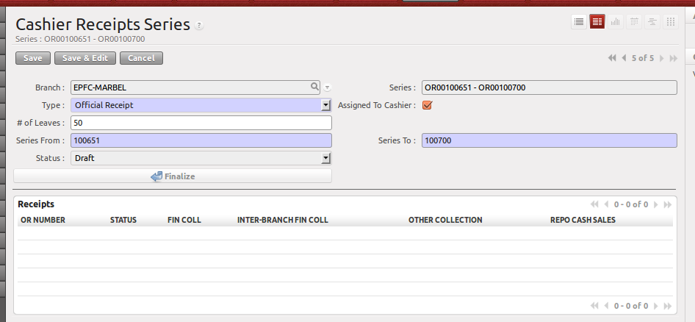
Menu
Loan >> Configuration >> Documentation >> Receipts

User
Branch Accounting Assistant

Type
Select from “Official Receipt” and “Temporary Receipt”

Assigned to Cashier
By default, this is checked. If the stub is issued to C.I/Collector, just uncheck this field.

# of Leaves
Input how many OR's in one stub.

Series From
First OR number in the stub. After which, the Series To will be automatically filled.

Series To
Computed by the system

Finalize Button
After thoroughly checked, click the Finalize button to populate the Receipts.

